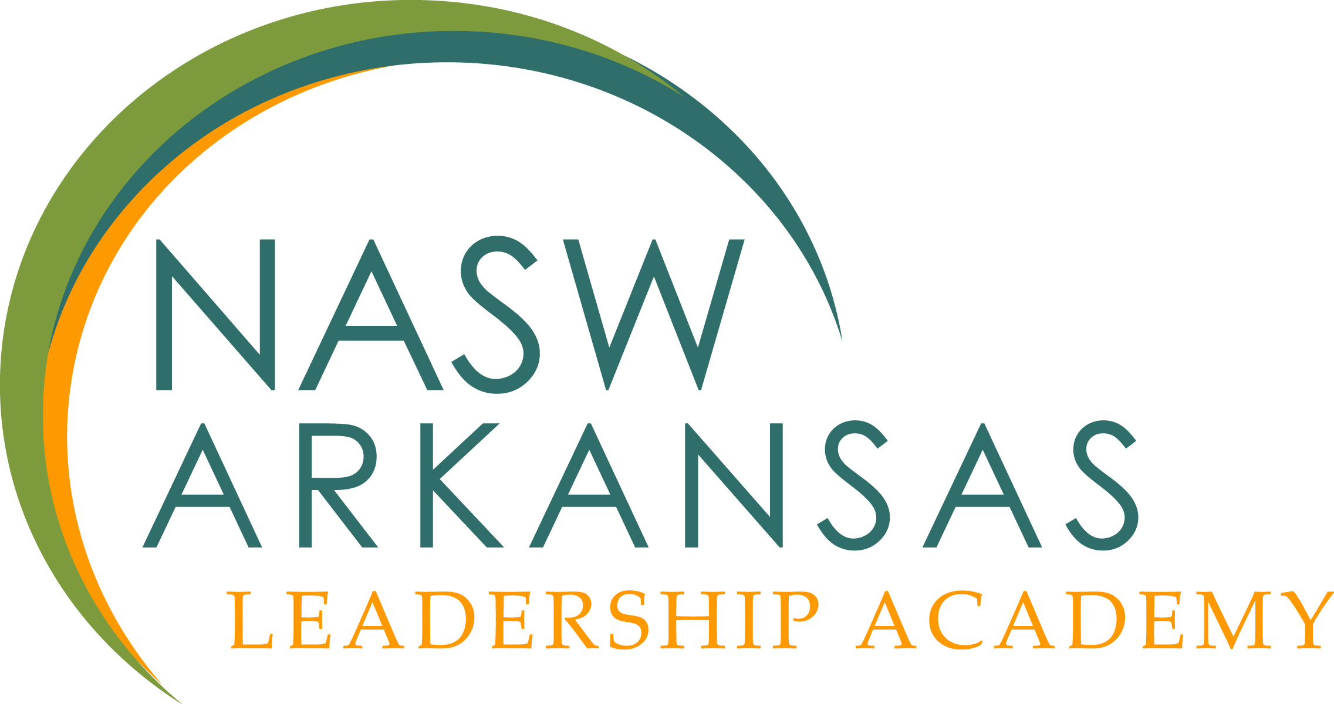

The NASW Arkansas Leadership Academy announces plans for the 2021 - 2022 academy from individuals who have demonstrated a capacity for leadership and who have the potential to make a substantial positive impact on the future of the field of social work. The academy will begin in September 2021 and end on March 31, 2022.

The purpose of the NASW Arkansas leadership program is to identify and develop leaders who will act as positive change agents for the field of social work and their respective agencies. The NASW Arkansas Leadership Academy supports the vision of NASW-AR by providing quality programs and experiences that will impact the state of Arkansas and empower the profession through education, networking, and advocacy. Participants have an opportunity to interact with colleagues and professionals from across the state to gain a better understanding of their personal leadership styles, build relationships, understand the issues facing leaders in social work, and gain the skills necessary to create positive change. Participants will earn up to 24 CEUs for full participation and receive 50% annual conference registration*.

NASW Arkansas leadership academy goals:

- Foster an environment where participants can build relationships and work across agency boundaries.
- Offer an opportunity for participants to identify problems and generate solutions for critical issues facing social work.
- Provide participants with the tools needed to develop and enhance their leadership skills, specifically in the areas of positive communication, strategic planning and problem solving, and collaboration.
- Develop leaders who can advocate for themselves, the profession, and the clients and communities they serve.
Criteria for Application: (application materials coming soon)

- Two or more years of professional work or relevant life experience.
- Professed interest in and commitment to leadership.
- Willingness to devote time and resources to the NASW Arkansas Leadership Academy.
- Demonstration of leadership skills.
- Demonstration of strong interpersonal skills and the ability to build relationships.
- Commitment of applicant’s supervisor for the applicant to participate in the Academy.
- Completion of interview if asked

Cost

- Tuition for this year long program is $375 for NASW-AR members/$480 for non-members.]
- There will be 2 to 3 in person day long sessions in Little Rock.
- Discount of 50% for NASW AR Annual Conference if Fellow attends and volunteers.
- Payment arrangements are available.

Time Commitment

- Significant time commitment with introductory meeting and two additional in-person education meetings
- Interaction with a mentor via phone or video conferencing
- Video conferencing for other education sessions and preparation of individual project
- Final presentation at the NASW AR 2022 conference

Sample Educational Topics

- Emotional Intelligence
- Self-Leadership in Social Work
- Transformational/Positive Leadership
- Board Management and Governance
- Crisis Management for Leadership
- Social Media in Leadership
- Grant Writing
- Non-profits
- Supervision and Mentorship
- Advocacy in Leadership

Application Packet 2021-2022

Applications are due by 5:00pm on August 1, 2021. Email your completed application in Word format only to: Holly Barron
hbarron.naswar@socialworkers.org

Applicant Information

Name: ________________________________

Are you an NASW member? No Yes Member Number: _________________________

Degree: BSW MSW Other. ______________________

Address: ____________________________________

Email: _______________________________________________

Cell # ___________________ Office # ____________________

Employer: __________________________________________________________________

Employer Phone Number: _________________________________________________________

Address: _______________________________________________________________________

Supervisor Name: ___________________________________

Director Name: _____________________________________

Please submit a resume that includes involvement in professional, business, or community organizations or other volunteer work.

Please answer the questions below (type your responses to the statements and questions below and attach to your application).

1. What are your leadership strengths and what areas would you like to improve?

2. What are your communication strengths and what areas would you like to improve?

3. What do you hope to learn by attending the NASW AR Leadership Academy and how will you use this knowledge to improve the profession of Social Work in our state?

4. One of the major requirements of the academy is the completion of a leadership project where you will use the knowledge gained in the academy in your agency. Additionally, your director and/or supervisor’s involvement is critical to your accountability and the implementation of this project into your agency. Keeping this in mind, answer the following questions.

- What are the key issues facing your agency and how do you see your participation in the NASW Arkansas Leadership Academy addressing those issues?
- How can your supervisor ensure your success?

Upon acceptance into the Academy, the participants and agencies will sign a Memorandum of Agreement to ensure full commitment to the Academy’s requirements.

In person sessions will be in September, November and January. Videoconferencing sessions will occur most months between September and March. We will set the date and times for all sessions based on fellows, organizers and presenters’ availability as we move forward.

